ITALIAN RENAISSENCE:
Renaissance Art and Architecture, painting, sculpture, and allied arts produced in Europe in the historical period called the Renaissance. Broadly considered, the period covers the 200 years between early 15th and early 17th centuries. The word renaissance literally means "rebirth" .The two principal components of Renaissance style are the following: a revival of the classical forms originally developed by the ancient Greeks and Romans, and an intensified concern with secular life–interest in humanism and assertion of the importance of the individual. The Renaissance period in art history corresponds to the beginning of the great Western age of discovery and exploration, when a general desire developed to examine all aspects of nature and the world.

Renaissance architecture:
is the architecture of the period between the early 15th and early 17th centuries in different regions of Europe, demonstrating a conscious revival and development of certain elements of ancient Greek and Roman thought and material culture. Stylistically, Renaissance architecture followed Gothic architecture and was succeeded by Baroque architecture. Developed first in Florence, with Filippo Brunelleschi as one of its innovators, the Renaissance style quickly spread to other Italian cities. The style was carried to France, Germany, England, Russia and other parts of Europe at different dates and with varying degrees of impact.
Renaissance style places emphasis on symmetry, proportion, geometry and the regularity of parts as they are demonstrated in the architecture of classical antiquity and in particular ancient Roman architecture, of which many examples remained. Orderly arrangements of columns, pilasters and lintels, as well as the use of semicircular arches, hemispherical domes, niches replaced the more complex proportional systems and irregular profiles of medieval buildings.

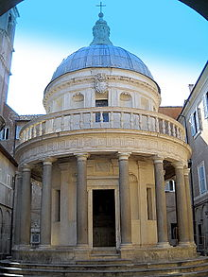
Tempietto di San Pietro in Montorio, Rome, 1502, by Bramante. This small temple marks the place where St Peter was put to death.

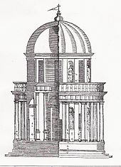 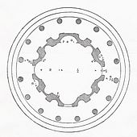 Plan of Bramante's Tempietto in Montorio
Palladio's engraving of Bramante's Tempietto

The archectural ers in Renaissance period are:
- Renaissance (ca. 1400–1500); also known as the Quattrocento and sometimes Early Renaissance
- High Renaissance (ca.1500–1525)
- Mannerism (ca. 1520–1600)

Quattrocento or Early Renaissance:
In the Quattrocento, concepts of architectural order were explored and rules were formulated. The study of classical antiquity led in particular to the adoption of Classical detail and ornamentation.
Space, as an element of architecture, was utilised differently from the way it had been in the Middle Ages. Space was organised by proportional logic, its form and rhythm subject to geometry, rather than being created by intuition as in Medieval buildings. The prime example of this is the Basilica di San Lorenzo in Florence by Filippo Brunelleschi.
High Renaissance
During the High Renaissance, concepts derived from classical antiquity were developed and used with greater surety. The most representative architect is Bramante (1444–1514) who expanded the applicability of classical architecture to contemporary buildings. His San Pietro in Montorio (1503) was directly inspired by circular Roman temples. He was, however, hardly a slave to the classical forms and it was his style that was to dominate Italian architecture in the 16th century.
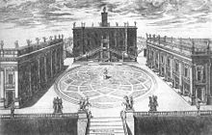

The Campidoglio

Mannerism:
During the Mannerist period, architects experimented with using architectural forms to emphasize solid and spatial relationships. The Renaissance ideal of harmony gave way to freer and more imaginative rhythms. The best known architect associated with the Mannerist style was Michelangelo (1475–1564), who is credited with inventing the giant order, a large pilaster that stretches from the bottom to the top of a façade. He used this in his design for the Campidoglio in Rome.
Prior to the 20th century, the term Mannerism had negative connotations, but it is now used to describe the historical period in more general non-judgemental terms.
As the new style of architecture spread out from Italy, most other European countries developed a sort of proto-Renaissance style, before the construction of fully formulated Renaissance buildings. Each country in turn then grafted its own architectural traditions to the new style, so that Renaissance buildings across Europe are diversified by region.

Characteristics
The obvious distinguishing features of Classical Roman architecture were adopted by Renaissance architects. However, the forms and purposes of buildings had changed over time, as had the structure of cities. Among the earliest buildings of the reborn Classicism were churches of a type that the Romans had never constructed. Neither were there models for the type of large city dwellings required by wealthy merchants of the 15th century. Conversely, there was no call for enormous sporting fixtures and public bath houses such as the Romans had built. The ancient orders were analysed and reconstructed to serve new purposes.

Plan
The plans of Renaissance buildings have a square, symmetrical appearance in which proportions are usually based on a module. Within a church, the module is often the width of an aisle. The need to integrate the design of the plan with the façade was introduced as an issue in the work of Filippo Brunelleschi, but he was never able to carry this aspect of his work into fruition. The first building to demonstrate this was St. Andrea in Mantua by Alberti.

Façade
Façades are symmetrical around their vertical axis. Church façades are generally surmounted by a pediment and organised by a system of pilasters, arches and entablatures. The columns and windows show a progression towards the centre. Domestic buildings are often surmounted by a cornice. There is a regular repetition of openings on each floor, and the centrally placed door is marked by a feature such as a balcony, or rusticated surround.
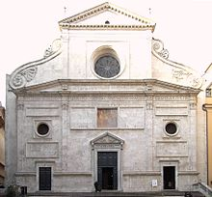
Sant'Agostino, Rome, Giacomo di Pietrasanta, 1483

Columns and pilasters
The Roman orders of columns are used:- Tuscan, Doric, Ionic, Corinthian and Composite. The orders can either be structural, supporting an arcade or architrave, or purely decorative, set against a wall in the form of pilasters. During the Renaissance, architects aimed to use columns, pilasters, and entablatures as an integrated system.
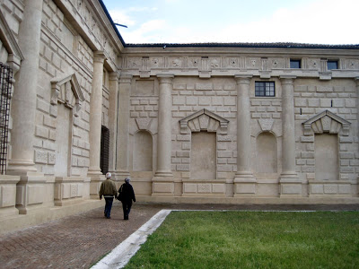
Arches
Arches are semi-circular element. Arches are often used in arcades, supported on piers or columns with capitals. There may be a section of entablature between the capital and the springing of the arch.
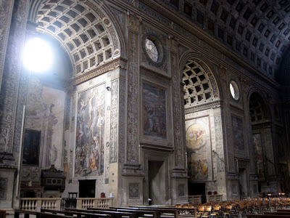

Vaults
Vaults do not have ribs. They are semi-circular or segmental and on a square plan, unlike the Gothic vault which is frequently rectangular. The barrel vault is returned to architectural vocabulary as at the St. Andrea in Mantua.
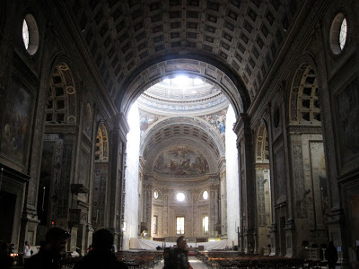

Domes:
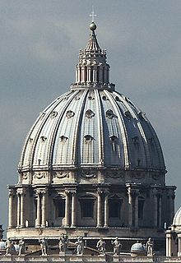
The Dome of St Peter's Basilica, Rome.
The dome is used frequently, both as a very large structural feature that is visible from the exterior, and also as a means of roofing smaller spaces where they are only visible internally. After the success of the dome in Brunelleschi’s design for the Basilica di Santa Maria del Fiore and its use in Bramante’s plan for St. Peter's Basilica (1506) in Rome, the dome became an indispensable element in church architecture and later even for secular architecture

Ceilings
Roofs are fitted with flat or coffered ceilings. They are not left open as in Medieval architecture. They are frequently painted or decorated.

Doors
Doors usually have square lintels. They may be set within an arch or surmounted by a triangular or segmental pediment. Openings that do not have doors are usually arched and frequently have a large or decorative keystone.

Windows
Windows may be paired and set within a semi-circular arch. They may have square lintels and triangular or segmental pediments, which are often used alternately. Emblematic in this respect is the Palazzo Farnese in Rome, begun in 1517.
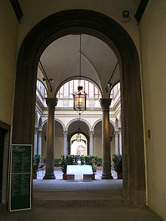
Courtyard of Palazzo Strozzi, Florence

Walls
External walls are generally constructed of brick, rendered, or faced with stone. The corners of buildings are often emphasised by rusticated quoins. Basements and ground floors were often rusticated, as at the Palazzo Medici Riccardi (1444–1460) in Florence. Internal walls are smoothly plastered and surfaced with lime wash. For more formal spaces, internal surfaces are decorated with frescoes.
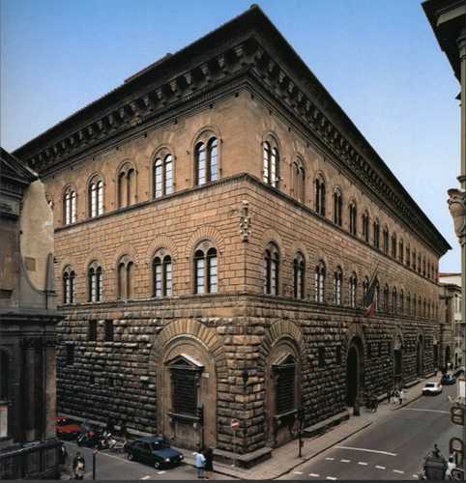

Development in Italy – Early Renaissance
The leading architects of the Early Renaissance or Quattrocento were Brunelleschi, Michelozzo and Alberti.

Filippo Brunelleschi

The person generally credited with bringing about the Renaissance view of architecture is Filippo Brunelleschi, (1377–1446). The underlying feature of the work of Brunelleschi was "order".
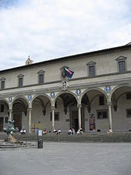
Ospedale degli Innocenti in Florence.
In the early 15th century, Brunelleschi began to look at the world to see what the rules were that governed one's way of seeing. He observed that the way one sees regular structures such as the Baptistery of Florence and the tiled pavement surrounding it follows a mathematical order—linear perspective.-
The buildings remaining among the ruins of ancient Rome appeared to respect a simple mathematical order in the way that Gothic buildings did not. One incontrovertible rule governed all Ancient Roman architecture—a semi-circular arch is exactly twice as wide as it is high. A fixed proportion with implications of such magnitude occurred nowhere in Gothic architecture. A Gothic pointed arch could be extended upwards or flattened to any proportion that suited the location. Arches of differing angles frequently occurred within the same structure. No set rules of proportion applied.
From the observation of the architecture of Rome came a desire for symmetry and careful proportion in which the form and composition of the building as a whole and all its subsidiary details have fixed relationships, each section in proportion to the next, and the architectural features serving to define exactly what those rules of proportion are.

Michelozzo
Michelozzo Michelozzi (1396–1472), was another architect under patronage of the Medici family, his most famous work being the Palazzo Medici Riccardi A decade later he built the Villa Medici at Fiesole. Among his other works for Cosimo are the library at the Convent of San Marco, Florence.
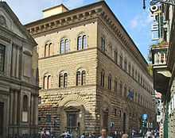
Palazzo Medici Riccardi by Michelozzo.
The Palazzo Medici Riccardi is Classical in the details of its pedimented windows and recessed doors, but, unlike the works of Brunelleschi and Alberti, there are no orders of columns in evidence. Instead, Michelozzo has respected the Florentine liking for rusticated stone. He has seemingly created three orders out of the three defined rusticated levels, the whole being surmounted by an enormous Roman-style cornice which juts out over the street by 2.5 meters.

High Renaissance
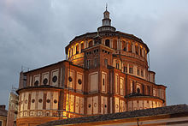
The crossing of Santa Maria della Grazie, Milan, Bramante (1490)
In the late 15th century and early 16th century, architects such as Bramante, Antonio da Sangallo the Younger and others showed a mastery of the revived style and ability to apply it to buildings such as churches and city palazzo which were quite different from the structures of ancient times. The style became more decorated and ornamental, statuary, domes and cupolas becoming very evident. The architectural period is known as the "High Renaissance

Bramante
Donato Bramante, (1444–1514), turned from painting to architecture, he produced a number of buildings over 20 years. After the fall of Milan to the French in 1499, Bramante travelled to Rome where he achieved great success
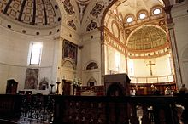
The apse of Santa Maria delle Grazie, Milan.
Bramante’s finest architectural achievement in Milan is his addition of crossing and choir to the abbey church of Santa Maria delle Grazie (Milan). This is a brick structure, the form of which owes much to the Northern Italian tradition of square domed baptisteries. The new building is almost centrally planned, except that, because of the site, the chancel extends further than the transept arms. The hemispherical dome, of approximately 20 metres across, rises up hidden inside an octagonal drum pierced at the upper level with arched classical openings. The whole exterior has delineated details decorated with the local terracotta ornamentation.

Sangallo
Antonio da Sangallo the Younger, (1485–1546), was one of a family of military engineers. Antonio da Sangallo also submitted a plan for St Peter’s and became the chief architect after the death of Raphael, to be succeeded himself by Michelangelo.
His fame does not rest upon his association with St Peter’s but in his building of the Farnese Palace, “the grandest palace of this period”, started in 1530. The impression of grandness lies in part in its sheer size, (56 m long by 29.5 meters high) and in its lofty location overlooking a broad piazza. It is also a building of beautiful proportion, unusual for such a large and luxurious house of the date in having been built principally of stuccoed brick, rather than of stone. Against the smooth pink-washed walls the stone quoins of the corners, the massive rusticated portal and the stately repetition of finely detailed windows give a powerful effect, setting a new standard of elegance in palace-building.
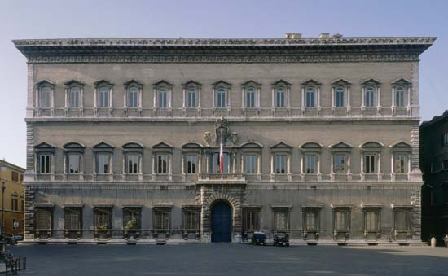
Farnese Palace

Mannerism
Mannerism in architecture was marked by widely diverging tendencies in the work of Michelangelo, Giulio Romano, Baldassare Peruzzi and Andrea Palladio, that led to the Baroque style in which the same architectural vocabulary was used for very different rhetoric.
Baldassare Peruzzi
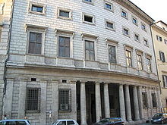
Palazzo Massimo alle Colonne.
Peruzzi’s most famous work is the Palazzo Massimo alle Colonne in Rome. The unusual features of this building are that its façade curves gently around a curving street. It has in its ground floor a dark central portico running parallel to the street, but as a semi enclosed space, rather than an open loggia. Above this rise three undifferentiated floors, the upper two with identical small horizontal windows in thin flat frames which contrast strangely with the deep porch, which has served, from the time of its construction, as a refuge to the city’s poor.

Michelangelo
Michelangelo Buonarroti (1475–1564) was one of the creative giants whose achievements mark the High Renaissance. He excelled in each of the fields of painting, sculpture and architecture and his achievements brought about significant changes in each area. His architectural fame lies chiefly in two buildings: the interiors of the Laurentian Library and its lobby at the monastery of San Lorenzo in Florence, and St Peter's Basilica in Rome.
St Peter's was "the greatest creation of the Renaissance", and a great number of architects contributed their skills to it. But at its completion, there was more of Michelangelo’s design than of any other architect, before or after him.

St Peter's
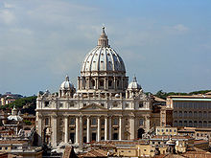
St Peter's Basilica
Michelangelo’s dome was a masterpiece of design using two masonry shells, one within the other and crowned by a massive lantern supported, as at Florence, on ribs. For the exterior of the building he designed a giant order which defines every external bay, the whole lot being held together by a wide cornice which runs unbroken like a rippling ribbon around the entire building.

Laurentian Library
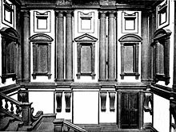
The vestibule of the Laurentian Library
Michelangelo was at his most Mannerist in the design of the vestibule of the Laurentian Library. The Library is upstairs. It is a long low building with an ornate wooden ceiling, a matching floor and crowded with corrals finished by his successors to Michelangelo’s design. But it is a light room, the natural lighting streaming through a long row of windows that appear positively crammed between the order of pilasters that march along the wall.
PAINTINGS:
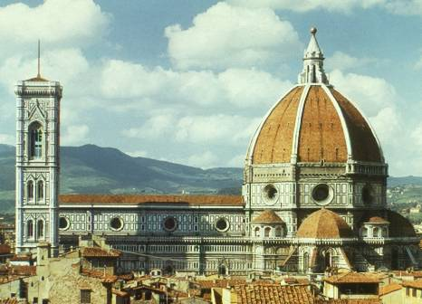

During the Renaissance, artists were no longer regarded as mere artisans, as they had been in the medieval past, but for the first time emerged as independent personalities, comparable to poets and writers. They sought new solutions to formal and visual problems, and many of them were also devoted to scientific experimentation. In this context, mathematical or linear perspective was developed, a system in which all objects in a painting or in low-relief sculpture are related both proportionally and rationally. As a result, the painted surface was regarded as a window on the natural world, and it became the task of painters to portray this world in their art. Consequently, painters began to devote themselves more rigorously to the rendition of landscape–the careful depiction of trees, flowers, plants, distant mountains, and cloud-filled skies. Artists studied the effect of light out-of-doors and how the eye perceives all the diverse elements in nature. They developed aerial perspective, in which objects become increasingly less distinct and less sharply colored as they recede from the eye of the viewer.
Although the portrait also developed as a specific genre in the mid-15th century. Renaissance painters achieved the greatest latitude with the history, or narrative, picture, in which figures located within a landscape or an architectural environment act out a specific story, taken either from classical mythology or Judeo-Christian tradition. Within such a context, the painter was able to show men, women, and children in a full range of postures and poses, as well as the subjects' diverse emotional reactions and states. The Renaissance of the arts coincided with the development of humanism in which scholars studied and translated philosophical texts. The use of classical Latin was revived and often favored at this time. The Renaissance was also a period of avid exploration; sea captains began to be more daring in seeking new routes to Asia, which resulted in the discovery and eventual colonization of North and South America. Painters, sculptors, and architects exhibited a similar sense of adventure and the desire for greater knowledge and new solutions; Leonardo da Vinci like Christopher Columbus discovered whole new worlds.
B. Early Renaissance Painting
The first painter to employ the new techniques was Masaccio. Despite a regrettably short career (he died at the age of 27), Masaccio had a dramatic effect on the course of art. He made use of both linear and aerial perspective in his frescoes depicting episodes in the life of Saint Peter for the Brancacci Chapel in Florence's Church of Santa Maria del Carmine. In the most famous of these scenes, the Tribute Money, Masaccio invested the figures of Christ and the apostles with a new sense of dignity, monumentality, and refinement. The Brancacci Chapel became a training ground for later painters, including Michelangelo, who copied Masaccio's figures.
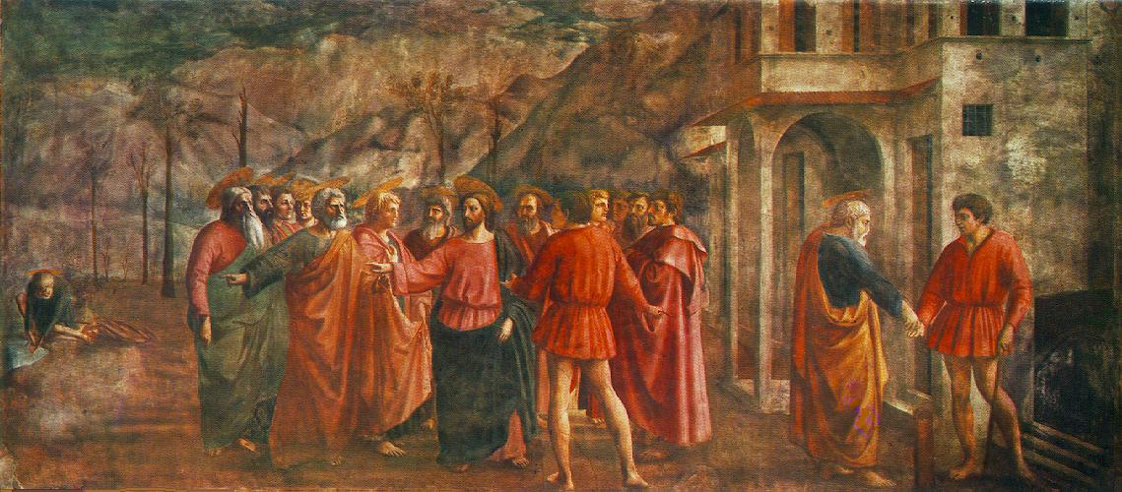

In the Trinity fresco (Santa Maria Novella, Florence), Masaccio created for the first time a convincing illusionistic space suggesting a chapel.
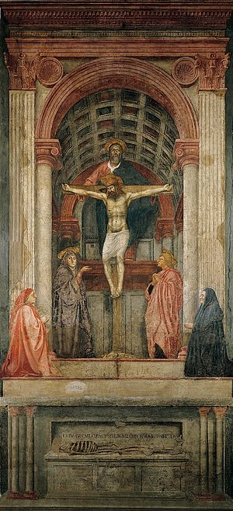
The direction taken by Masaccio was shared by his contemporaries, including Paolo Ucccello who was much taken with the pictorial potentialities of linear perspective. Among his finest works are three battle scenes (Uffizi, Florence; National Gallery, London; Louvre, Paris) made in the late 1440s for the Medici Palace in Florence, in which all the participants are shown sharply foreshortened.
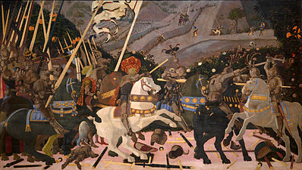
He also did the large fresco Sir John Hawkwood (1436, Florence Cathedral), painted to simulate a bronze equestrian monument, a type known from Roman examples and soon to be revived in freestanding sculpture by Donatello. Another master of the same period was Fra Angelico a monk, whose refined style combined the rugged new Renaissance forms with delicacy of color and treatment. Fra Angelico was particularly innovative in painting tree-filled landscapes. His works include a series of fresco decorations painted in the 1430s and 1440s for his fellow Dominicans at the Convent of San Marco in Florence.
The art of the early Renaissance is summed up in many ways by the work of Leon Battista Alberti a humanist, a Latin scholar, and a prolific writer, Alberti was trained in north Italy because his family had been expelled from Florence. He had some direct experience with painting and sculpture and was an inventive architect. Among his influential designs was the facade (completed 1458) of Santa Maria Novella in Florence, in which Alberti developed a flattened temple-front system, which was later widely adopted. He also designed several churches in Mantua (Mantova), including Sant' Andrea (completed 1494). Of equal importance to his buildings were his theoretical works on painting, sculpture, and architecture. In these books Alberti synthesized all the innovations of his contemporaries and also included ancient practices. As a result of his writings, the new ideas were propagated throughout Italy and beyond. He dedicated his book on painting to Brunelleschi, as well as to Ghiberti, Donatello, Luca Della Robbia, and Masaccio.
The Second Generation of Renaissance Artists:
In north Italy, the leading painters of the second generation were Andrea Mantegna from Padua and Giovanni Bellini from Venice. Mantegna was active in both Verona and Rome for a short time. The fresco decoration of the Camera degli Sposi (1465-1474) in the Doge's Palace (Palazzo Ducale) is considered one of his masterpieces. He extended the boundaries of painting by opening out the walls and the ceiling in a unified fresco program to give the impression of a much larger space, where the real and the painted worlds become difficult to separate.
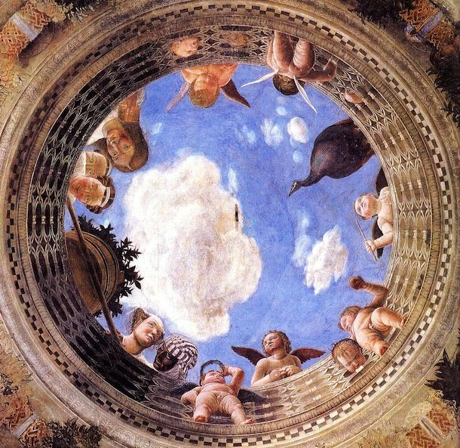
His trompe l'oeil ("fool-the-eye") approach was continued by many mural painters during the following two centuries, especially in the vast illusionistic baroque ceilings for churches and palaces.
Another leading painter of the second generation was Sandro Botticelli. His art is lyric, flowing, and often decorative in appearance, whether on religious or pagan subjects. His two most famous works, both in the Uffizi Gallery, are the Birth of Venus (after 1482) and Primavera or Spring .The figural type in the Venus is based on an antique statue, but here she is shown standing on a shell emerging from the pale blue sea from which she was born. Botticelli made powerful use of heavy outlines in establishing this elegant image; modeling with light to dark tonalities (chiaroscuro) is kept to a minimum.

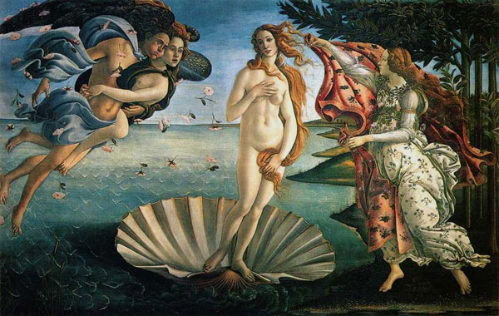
The Birth of Venus
Artists of the High Renaissance:
The artists of the following generation were responsible for taking art to a level of noble expression. This period, usually referred to as the High Renaissance, was initiated by Leonardo da Vinci, who, when he returned to Florence from Milan in 1500, found the milieu ready for his pictorial inventions. There he found the young Michelangelo, who was about to begin the famous gigantic statue David (1501-1504, Academia). This bold image soon became not only the symbol of the city of Florence, but of High Renaissance art as well, and a standard against which other works were measured. David as a subject has all the potentiality for vigorous, forceful action, but Michelangelo chose to show instead his self-control the moment before the encounter with Goliath, much as Leonardo had done with the figures of the apostles in the Last Supper (1495-1497, Santa Maria delle Grazie, Milan) by choosing to depict the moment just after Christ has said that one of them will betray him. During the High Renaissance, artists tended to reduce their subjects to the bare essentials; few extraneous details or anecdotal features were permitted, ensuring that the viewer's attention would be focused on the essence of the theme.
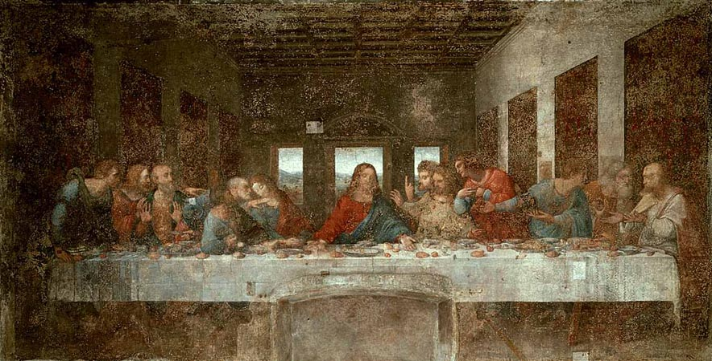
the Last Supper
Raphael, who was born in Umbria, was among those painters attracted to Rome. A pupil of Perugino, Raphael studied in Florence at a time when Leonardo and Michelangelo were there, helping to form the artistic language of the High Renaissance. Raphael went to Rome in 1508 and remained there until his death in 1520. He became the city's leading painter and formed an active shop with many assistants. In addition to a series of distinguished portraits of Pope Julius II and other notables, as well as smaller altarpieces

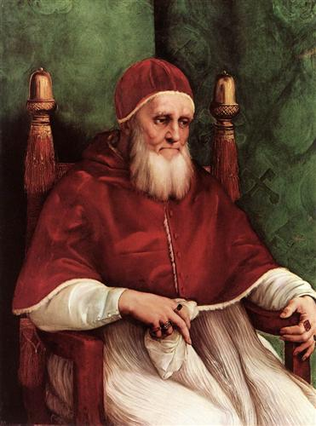
Pope Julius II
Raphael's works include fresco decorations (1508-1517) for the Stanze, a suite of four rooms in the Vatican Palace. The most important are those in the Stanza della Segnatura, which contains the Disputà, an elaborate explication of the sacrament of the Eucharist. Churchmen discuss the doctrine in the lower zone; above them, Christ and a heavenly company are shown in a sweeping semicircle.
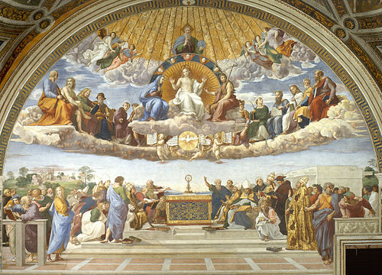

Tiziano Vercellio, better known as Titian, was the most gifted High Renaissance painter in Venice. Among his most admired early works is Sacred and Profane Love ( Galleria Borghese, Rome), an allegorical picture in which two women, one nude (Sacred Love) and the other fully clothed (Profane Love), are seated opposite each other in a serene manner reminiscent of Giorgione's mysterious world. The Assumption of the Virgin (1516-1518), a huge oil painting for the main altar of Santa Maria dei Frari in Venice, is one of Titian's masterpieces. The figure of the Virgin is depicted soaring above the apostles and moving toward God the Father, shown in the curved top of the painting. Warm tones, such as vivid reds and golden yellows, dominate.

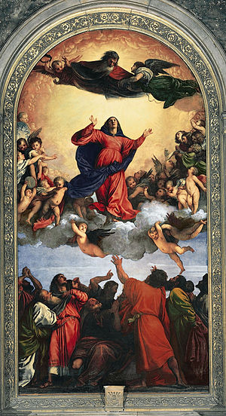
Assumption of the Virgin
In his long career, Titian produced many important works for his patron, Holy Roman Emperor Charles V, who made the painter a member of the nobility. Among these pictures were several portraits of the Habsburg monarch, including one of the emperor on horseback, Charles V at the Battle of Mühlberg (1548, Prado). This equestrian image became the prototype for state portraits during the next two centuries. Titian continued to paint even in extreme old age, and his characteristic free brushwork, vivid color, monumental figure types, and masterly idealized landscapes continued to mark his art. This is most evident in Crowning with Thorns ( Alte Pinakothek, Munich), in which the forms seem dissolved by a maze of pure light, color, and pigment.

SCULPTURES:
Early Renaissance Sculpture:
Sculptors led the way in introducing the new Renaissance forms early in the 15th century. Three Florentines, who were originally trained as goldsmiths, made crucial innovations.
The eldest was Filippo Brunelleschi, who developed linear perspective. He eventually became an architect, the first truly Renaissance builder, and in that capacity designed the enormous octagonal dome of Florence Cathedral, also called the Duomo, completed in 1436. The dome was considered one of the most impressive engineering and artistic feats since Roman times. Filippo was responsible for the revival of the classical columnar system, which he studied in Rome. He introduced into all his public and private structures a new formal spatial integrity that was unique to the Renaissance.

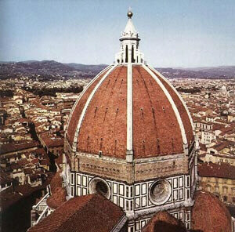
The Dome of Florence Cathedral
by Filippo Brunelleschi
1418-1436, Florence, Italy

Lorenzo Ghiberti is best known for the reliefs he made for two sets of gilded bronze doors, produced for the Florence Baptistery. His second pair of doors, illustrating Old Testament themes, was highly praised by Michelangelo, who termed them worthy of the Gates of Paradise, which they have been called since then.
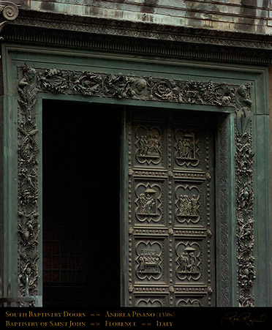
Donato di Niccolò di Betto Bardi, known as Donatello, was one of the most influential artists of the Renaissance, not only because of the power of his figures but also because he traveled widely. A Florentine, Donatello also worked in Venice, Padua (Padova), Naples, and Rome and was thereby instrumental in carrying the new Florentine innovations to much of Italy. His principal works include the bronze David (1430?-1435, Bargello, Florence), an image of the biblical hero with the head of Goliath at his feet. The nearly life-size nude figure, conceived in the round, was the first such statue made since ancient times.
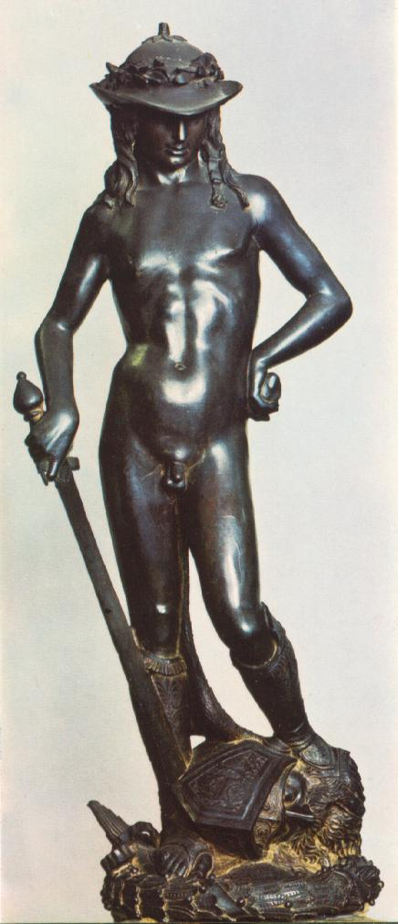
Another major work is the marble Cantoria, or Singing Gallery ( Museo dell' Opera del Duomo, Florence), made for Florence Cathedral, with scores of frolicking nude children (putti), which became favorite subjects in Renaissance art. Donatello, who also worked in terra-cotta and wood, made use of Brunelleschi's perspective devices in his reliefs. His dignified and expressive freestanding statues, often representing saints, became a measure of excellence for the next hundred years.

The Second Generation of Renaissance Artists:
In the subsequent generation, the innovations in aerial and linear perspective, the rendition of landscape, the powerful figural types, and the rigorous compositions were consolidated and further refined. Artists such as Antonio del Pollaiuolo and Amdrea del Verrocchio explored the complexities of human anatomy, studying directly from life. Both were sculptors as well as painters, and their figures show a new concentration on musculature, as exemplified by Pollaiuolo's masterpiece, the Martyrdom of Saint Sebastian (1475, National Gallery, London).
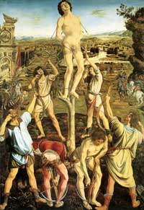

Martyrdom of St Sebastian, 1473-75, National Gallery, London
Pollaiuolo also made two important bronze papal tombs, the tomb (1484-1493) of Sixtus IV and the tomb (1493-1497) of Innocent VIII, which are both in the Grotte Vaticane, Saint Peter's Basilica, Rome. The concerns of Pollaiuolo and Verrocchio were later taken up by Leonardo da Vinci Verrocchio's greatest pupil, whose scientific and artistic investigations were among the most important of the Renaissance. Leonardo was active in all the various arts as well as in a score of other fields.

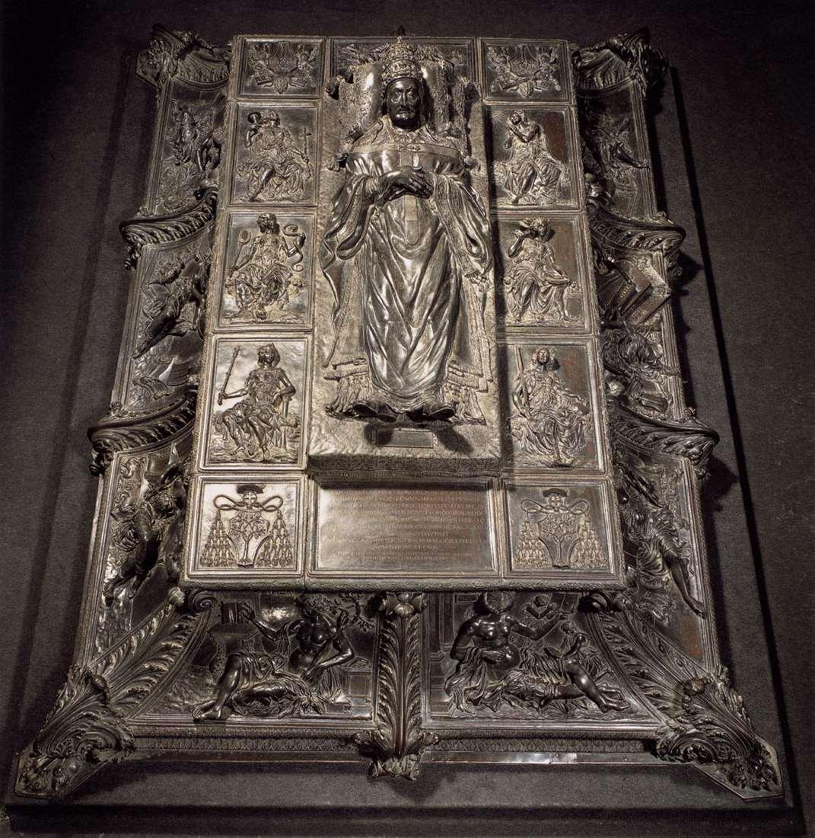
The tomb by Pollaiuolo

